AEMO’s Data

Most of the data used in this project is publicly sources from AEMO. To ensure the results presented in this project can be reproduced, this document is dedicated to outlining how AEMO’s data was gathered, processed, and used throughout the modelling. This document is split into key two sections that explore the creation of the generation traces and demand traces, respectively.

Overview of AEMO’s Scenarios

Before delving into the data, it is important to first outline the data scenario. A high-level overview of AEMO’s future scenarios is depicted in Table 1. The most likely scenario, as voted for by the Delphi Panel, is the *Step Change* scenario. This scenario balances the forecasts of the *Green Energy Exports* scenario and the *Progressive Change* scenario. For in-depth discussion of the differences between scenarios, refer to the ISP [79].

**Table 1:** Summary of differences between AEMO scenarios recrated from the ISP [33].

|  |  |  |  |
| --- | --- | --- | --- |
| Parameter | Green Energy Exports | Step Change | Progressive Change |
| **National Decarbonisation Target** | At least 43% emissions reduction by 2030*. | National Decarbonisation Target | At least 43% emissions reduction by 2030*. |
| **Global Economic Growth and Policy Coordination** | High economic growth, stronger coordination. | Moderate economic growth, stronger coordination. | Slower economic growth, lesser coordination. |
| **CER Uptake (Batteries, PV and EVs)** | Higher | High | Lower |
| **Hydrogen Use** | High production for domestic and export use. | Medium-low production for domestic use, with minimal export hydrogen. | Low production for domestic use, with no export hydrogen. |
| **Global/domestic temperature settings and outcomes\*\*** | Limit temperature increase to ~1.5°C. Based on Represented Concentrated Pathway (RCP) 1.9 | Limit temperature increase to ~1.8°C. Based on RCP 2.6 | Limit temperature increase to ~2.6°C. Based on RCP 4.5 |
| **Probability (Based on Delphi Panel)** | 15% | 43% | 42% |

*Emission levels compared to 2005 levels as stated in the Paris Agreement [116].

**Temperature limits with respect to global surface temperatures of 1850-1900 levels [117].

# Generation Data

The following chapter is split into three sections. The first section outlines how AEMO uses rolling reference years to model short to medium term weather diversity using historic data. This leads into a brief discussion on how REZs are chosen by AEMO and how these were mapped to the regions used in the project. The final section breaks down how AEMO’s data was sourced in order to create the generation traces.

## Rolling Reference Years

To model short- and medium-term weather diversity, AEMO uses reference years. Table 2 below outlines the reference years for each planning year considered in this report.

**Table 2:** AEMO’s rolling reference year list [114].

|  |  |
| --- | --- |
| Planning Year | Reference Year |
| 2024-25 | 2018-19 |
| 2025-26 | 2019-20 |
| 2026-27 | 2020-21 |
| 2027-28 | 2021-22 |
| 2028-29 | 2022-23 |
| 2029-30 | 2014-15* |
| 2030-31 | 2010-11 |
| 2031-32 | 2011-12 |
| 2032-33 | 2012-13 |
| 2033-34 | 2013-14 |
| 2034-35 | 2014-15 |
| 2035-36 | 2015-16 |
| 2036-37 | 2016-17 |
| 2037-38 | 2017-18 |
| 2038-39 | 2018-19 |
| 2039-40 | 2019-20 |
| 2040-41 | 2020-21 |
| 2041-42 | 2021-22 |
| 2042-43 | 2022-23 |
| 2043-44 | 2014-15* |
| 2044-45 | 2010-11 |
| 2045-46 | 2011-12 |
| 2046-47 | 2012-13 |
| 2047-48 | 2013-14 |
| 2048-49 | 2014-15 |
| 2049-50 | 2015-16 |
| 2050-51 | 2016-17 |
| 2051-52 | 2017-18 |

*2014-15 is considered a dry year. This represents drought conditions, affecting water inflows is hydro generators [115]. This is not necessarily crucial to SA itself as there is forecast to be no hydro generation development, however, it is a consideration in models that use interconnectors into other states.

## Identification of REZs

REZs are identified based on 10 development criteria [79] that were originally created in a report by Det Norske Veritas [118]. The report details how each criterion was mapped, weighted and scaled for the assessment of REZs. The development criteria, as outlined by AEMO, are reproduced below:

* Wind resource: a measure of high wind speeds (above 6m/s)
* Solar resource – a measure of high solar irradiation (above 1,600 kW/m2).
* Demand matching – the degree to which the local resources correlate with demand.
* Electrical network – the distance to the nearest transmission line.
* Cadastral parcel density – an estimate of the average property size
* Land cover – a measure of the vegetation, waterbodies, and urbanisation of areas.
* Roads – the distance to the nearest road.
* Terrain complexity – a measure of terrain slope.
* Population density – the population within the area.
* Protected areas – exclusion areas where development is restricted.

The original REZs identified by Det Norske Veritas in conjunction with consultation of the 2018, 2020 and 2022 ISPs has led to the REZs as seen in the current ISP [79]. It should thus be noted that in future iterations of the ISP, the REZs may change. The current REZs in SA are depicted in Figure 1.

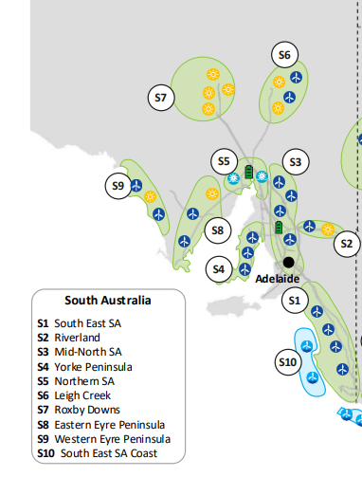

**Figure 1:** REZs in SA and the renewable resources available in each [119].

The mapping of AEMO’s REZs to the honours regions is shown in Table 3 and is visually displayed in Figure 2. To create generation trace data for each honours region, the trace data of generators contained in the region are aggregated.

**Table 3:** Mapping of REZs to the honours regions.

|  |  |
| --- | --- |
| Honours Region | REZs Included |
| Adelaide Metro | Non-REZ |
| Eyre Peninsula | Western Eyre Peninsula, Eastern Eyre Peninsula |
| Iron Triangle | Northern SA |
| Upper North | Roxby Downs and Leigh Creek |
| Mid North | Mid North SA and Yorke Peninsula |
| Riverland | Riverland |
| South East | South East SA and South East Coast SA |

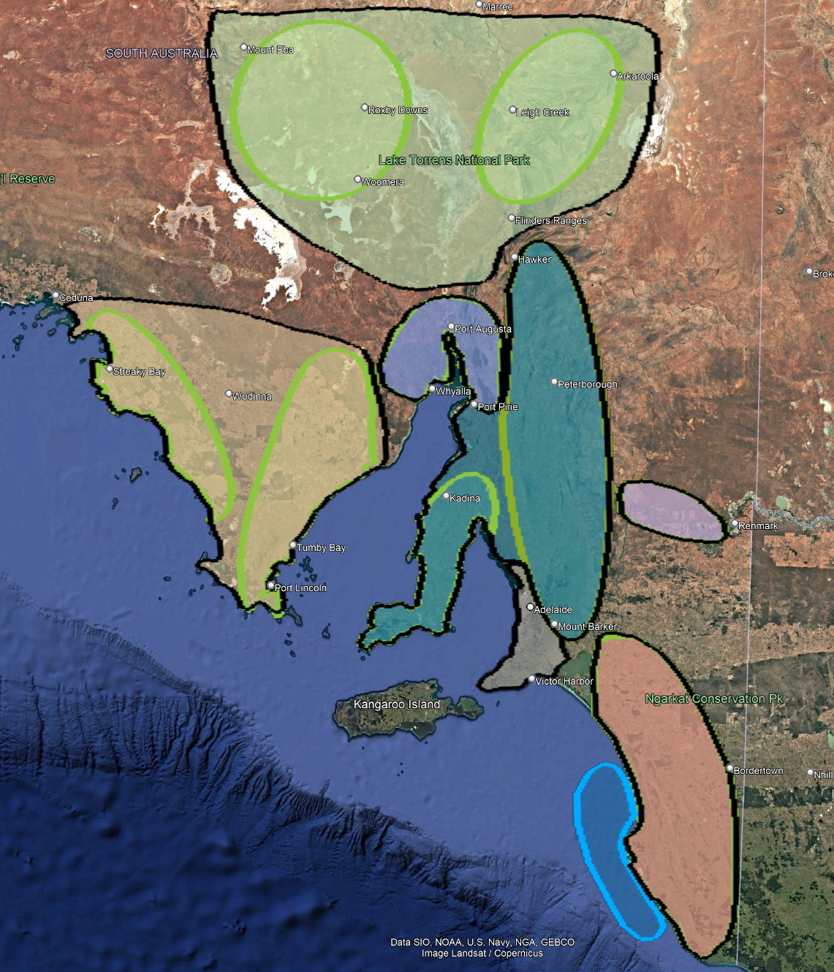

**Figure 2:** A visual depiction of the mapping between AEMO’s REZs and the honours regions.

## Generation Data Breakdown

AEMO provides generation trace data for each REZ and current renewable generation site in the NEM. However, these traces contain a floating-point number ranging from 0 to 1, with 0 representing no output at the site for a given time interval and 1 representing the maximum output at the site for a given time interval. Therefore, the first step to create the generation trace data was to determine the existing renewable generator capacities. The second step was to calculate the forecasted development in each REZ using AEMO’s ISP workbook and the existing installed capacity in each REZ. Finally, the time series generation traces were created. The subsequent three subsections describe the process and code used to carry out the aforementioned steps, respectively.

### Existing Generators

AEMO’s Inputs and Assumptions workbook contains a complete list of inputs and assumptions used in the creation of the ISP, with information relating to existing renewable energy generator capacities. The generator information is based on the data published in AEMO’s Generation Information workbook [84]. Since AEMO’s Generation Information workbook contains the most up to date information, it is used in conjunction with the IASR workbook to ensure that any changes in renewable generation capacities are correctly reflected in the developed generation traces.

The most recent iteration of the IASR was published for the 2024 ISP in June of 2024. The IASR workbook can be found under the “Supporting Materials” section of AEMO’s ISP webpage and is labelled “2024 ISP Inputs and Assumptions Workbook”, as shown in Figure 3. The relevant worksheet for the generation information is the “Existing Gen Data Summary”, see Figure 4. The three relevant tables in this worksheet are the existing generators, the committed generators, and the anticipated projects.

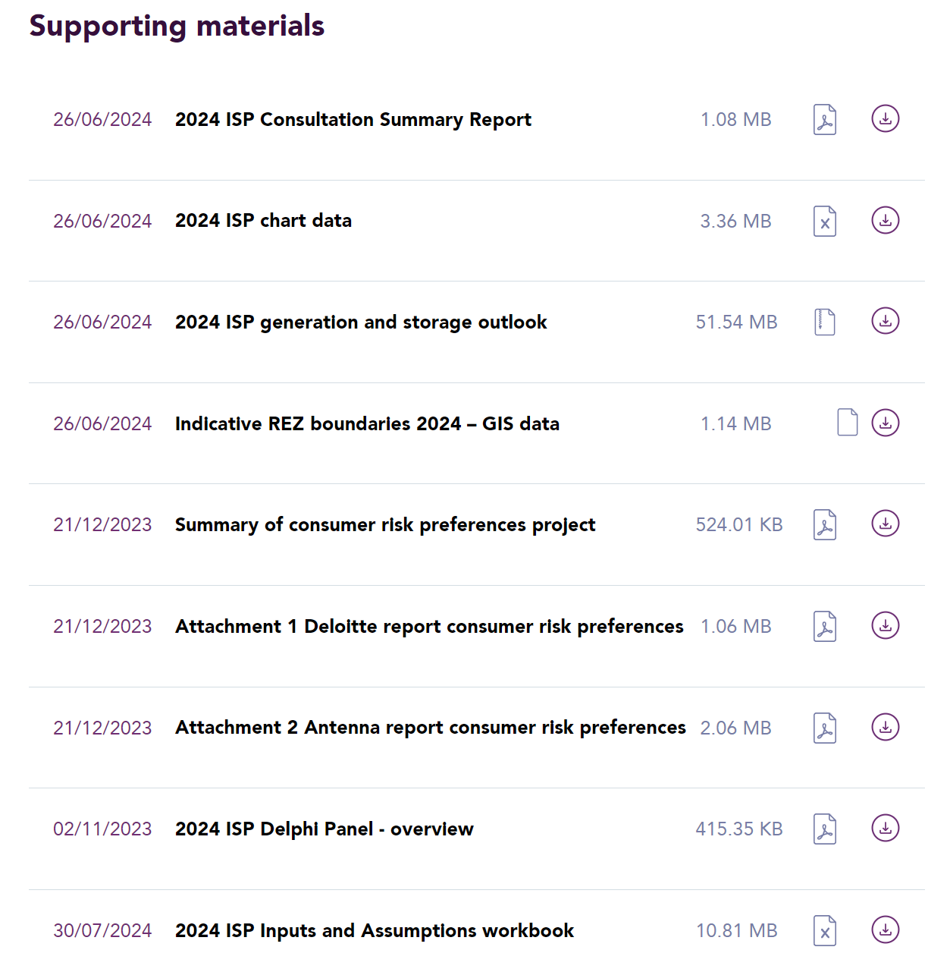

**Figure 3:** Location of AEMO’s ISP Inputs and Assumptions workbook.

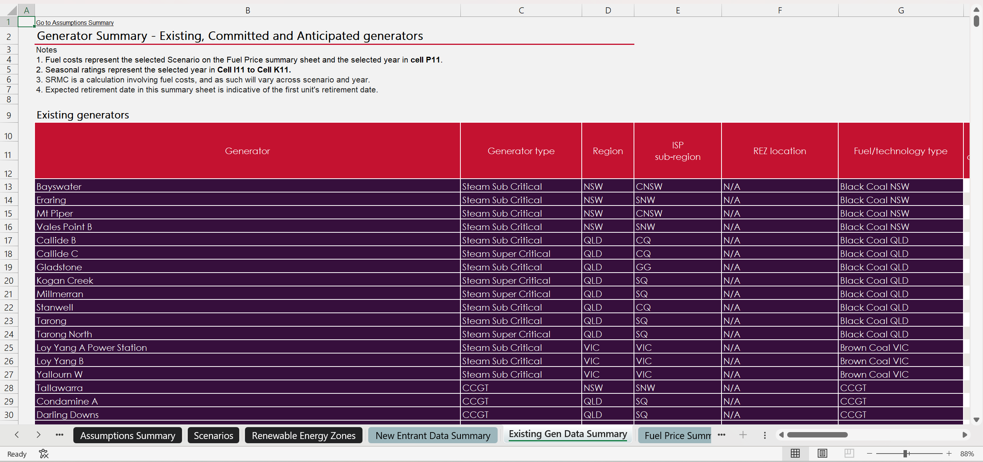

**Figure 4:** Existing Gen Data Summary worksheet is the Inputs and Assumptions workbook.

Wind and large-scale solar PV generator information relating to SA was copied from the tables and pasted in a new spreadsheet in the format shown in Table 4.

**Table 4:** Example data collection format from AEMO’ Inputs and Assumptions workbook.

|  |  |  |
| --- | --- | --- |
| Site Name | REZ | Type |
| <Site Name> | <SA REZ> | <Solar/Wind> |

While the Inputs and Assumptions workbook provides the seasonal ratings, expected retirement year, and expected commencement data of committed and anticipated generators, this information can be out of date. Therefore, AEMO’s Generation Information can be used to obtain up to date information on these statistics. The generator information was found at AEMO’s Generation Information page under the “NEM Generation Information Publications” section [84]. This workbook is updated almost on a monthly basis, tracking statistics related to all large-scale generators in the NEM.

After downloading the workbook, the “Scheduled Capacities” worksheet was filtered for generators in SA. This is shown Figure 5 below.

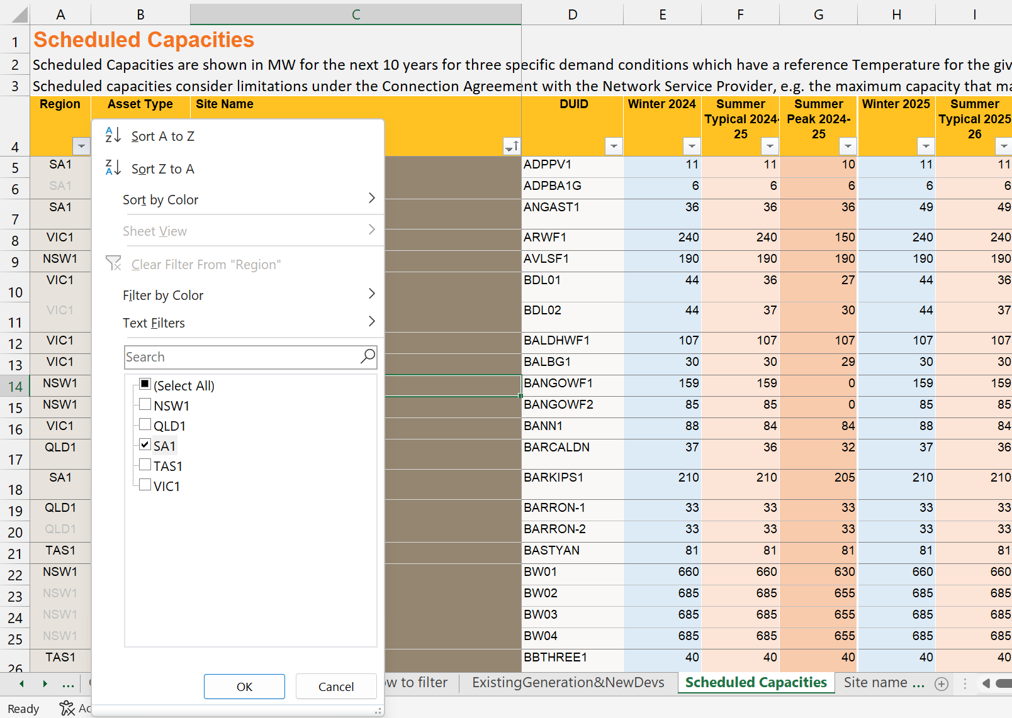

**Figure 5:** Filtering the NEM Generation Information workbook for SA generators.

Since this project is focused on renewable energy sources only, the “Technology Type” column is then filtered for “Solar PV – Fixed”, “Solar PV – Single axis tracking” and “Wind Turbine – Onshore”. The information crucial to gather from this table was the winter, summer typical, and summer peak ratings for each of the generators. For the generators still in the project stage, multiple years of ratings was gathered as the ratings for these sites changes as partial amount of their rated capacity is released in the development stages. An example of this is shown by the green boxes in Figure 6. The other important information gathered from this worksheet was the expected retirement years of each generator which can be obtained in the “Expected Closure Year” column.

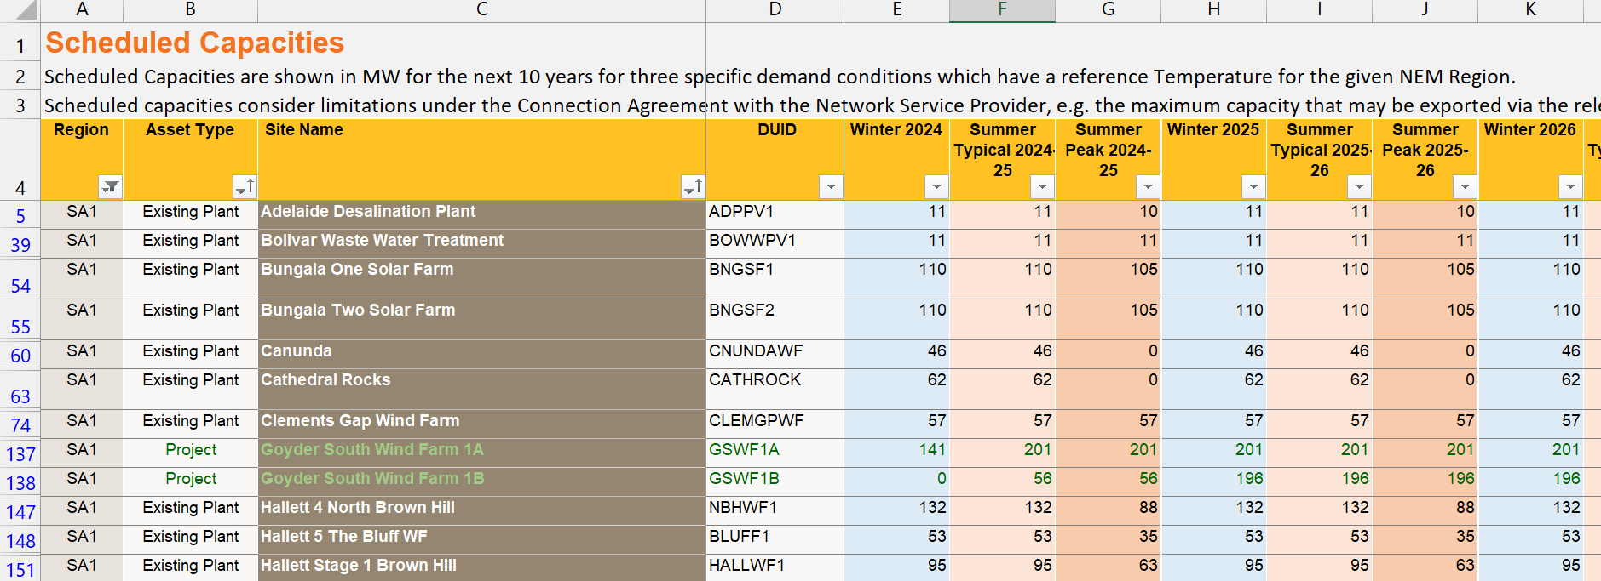

**Figure 6:** Example of a generator having different rated capacities as construction completes.

The information was added as additional columns to Table 4. One observation was that Cultana solar farm and Mt Millar wind farm were not Scheduled Capacities worksheet. Cultana solar farm was not listed due to it being in the early stages of development while Mt Millar was not listed because it is a non-scheduled generator, meaning it does not participate in the central market dispatch.

To find the required information for these generators, a similar process was repeated in the “ExistingGeneration&NewDevs” worksheet. Upon filtering the “ExistingGeneration&NewDevs” worksheet, all generating units, including non-utility scale generators, generators with a capacity less than 5MW, were listed. The nameplate capacity for the two generators was obtained and applied to each seasonal rating since their ratings are not broken down by season.

As a final check, the gathered seasonal ratings from the Generation Information workbook were checked against the ones listed in the IASR workbook. Cultana solar farm’s nameplate capacity was listed at 357MW in the NEM Generation Information whereas its capacity in the IASR workbook was listed at 280MW. Upon looking through other resources [125], [126], [127], Cultana’s seasonal ratings were set to 280MW.

The next step was to create a table in Excel that listed the capacity of each generator for each year in AEMO’s forecast period. Three separate tables were created, one for the winter ratings, one for the summer ratings, and one for the peak ratings. These tables are omitted from this report due to their size and the lack of new information contained within them. This leads into the next phase of generation development which is creating the future forecast capacities.

### Future Generators

In AEMO’s ISP workbook, the renewable energy capacity of each REZ over AEMO’s forecast period is listed. These values are inclusive of both existing generators and forecasted generator development. Thus, to ensure there is no double counting, the current generator capacities need to be removed. This is why the current generator information was acquired first.

The ISP workbook can was found on the 2024 Integrated System Plan page, under the Supporting materials section in a file named “2024 ISP Generation and Storage Outlook”, see Figure 7.



**Figure 7:** Location of AEMO’s 2024 ISP Generation and Storage Outlook workbook.

After downloading this zip file, both AEMO’s core and sensitivity workbooks were available. Since this report focuses on the *Step Change* scenario, the “2024 ISP – Step Change – Core” workbook was used. Contained within the workbook is a worksheet named “REZ Generation Capacity”, as shown in Figure 8, that contains the solar and wind generation capacity in each REZ, in each CDP for the *Step Change* scenario. Since the ODP is CDP14, only data from this CDP was used. The renewable capacities for the SA REZs were taken and placed in a separate workbook.

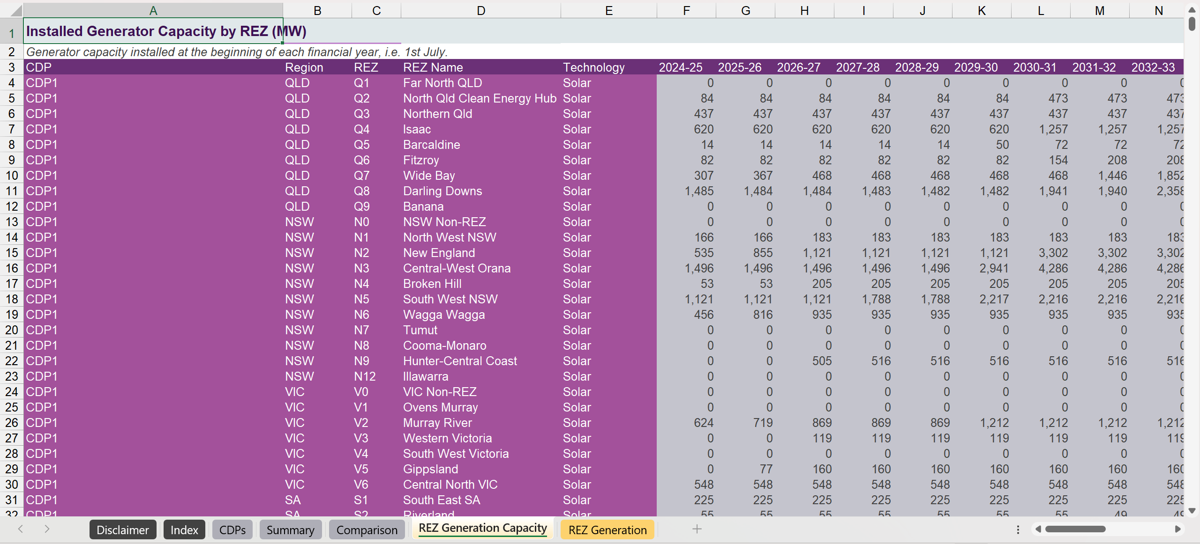

**Figure 8:** AEMO’s REZ Generation Capacity worksheet.

To remove the current generator capacities, the following is performed.

* For the current generators, calculate the sum of the winter rating for each solar and wind REZ over each year. This was achieved using a pivot table in Excel to increase reliability and to speed up the operation.
* Subtract the respective sums from the ISP workbook data. This was achieved using a formula that matches the year, technology type, and REZ with the information in the pivot table.

In some instances, there were small rounding errors, resulting in a REZ having an erroneous capacity value in the order of watts. In these cases, the data was manually zeroed. There were also instances where values were off by a few MW. In these cases, the specific current REZ sites were investigated, and values change slightly between the Generation Information workbook and the IASR workbook. This fixed the remaining erroneous values.

### Creating Generation Trace Data

The final stage to create the generation trace data was to create half hourly trace data for each existing site and REZ over AEMO’s forecast period. AEMO provides solar and wind trace data in the Supporting Materials section under the ISP model. The files that were downloaded are shown in Figure 9.

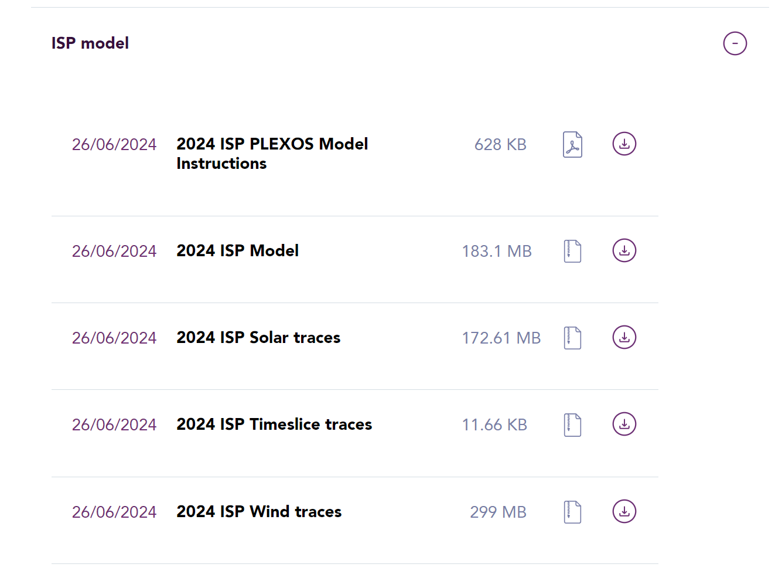

**Figure 9:** Solar and wind trace data files.

**Solar Trace Data**

Generation trace data for each REZ is split into concentrated solar thermal (CST) and single axis tracking (SAT). At the time of writing, there is one proposed CST in SA from Vast Solar with a nameplate capacity of 34MW [13]. Furthermore, AEMO does not disclose the amount of REZ solar resources that could be devoted to CST [79]. Due to the aforementioned points and the fact that CST development in Australia has been low compared to solar PV [128], future solar developments have been assumed to be solar PV only.

Current utility scale solar PV arrays are both SAT and fixed flat plate (FFP). SAT can generate a larger amount of energy, compared to FFP, as the panels can track the sun about a single axis. Dual axis tracking (DAT) is another technology that enables the panels to track the sun about both axes. However, SAT generally offers the best cost benefit compared to the other technologies and thus the REZ generation traces consist of figures for SAT systems only [79].

Single axis and dual axis solar trackers aim to increase the energy output of solar panels by tracking the sun as it moves in the sky. An example of a SAT is shown in Figure 10 and an example of a DAT is shown in Figure 11. A comparison of the power output of fixed, SAT and DAT is presented in Figure 12.

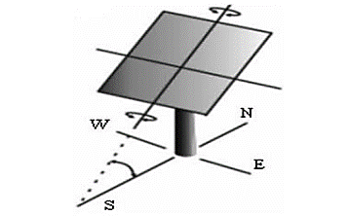

**Figure 10:** Diagram of a SAT. Note that the study was conducted in the northern hemisphere and hence is why the panel is facing south [129].

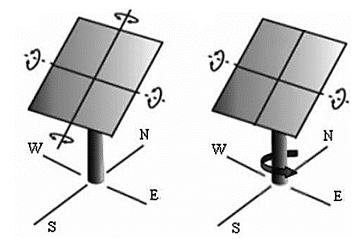

**Figure 11:** Two ways of achieving DAT. As before, the study was conducted in the northern hemisphere and so the panels face south [129].

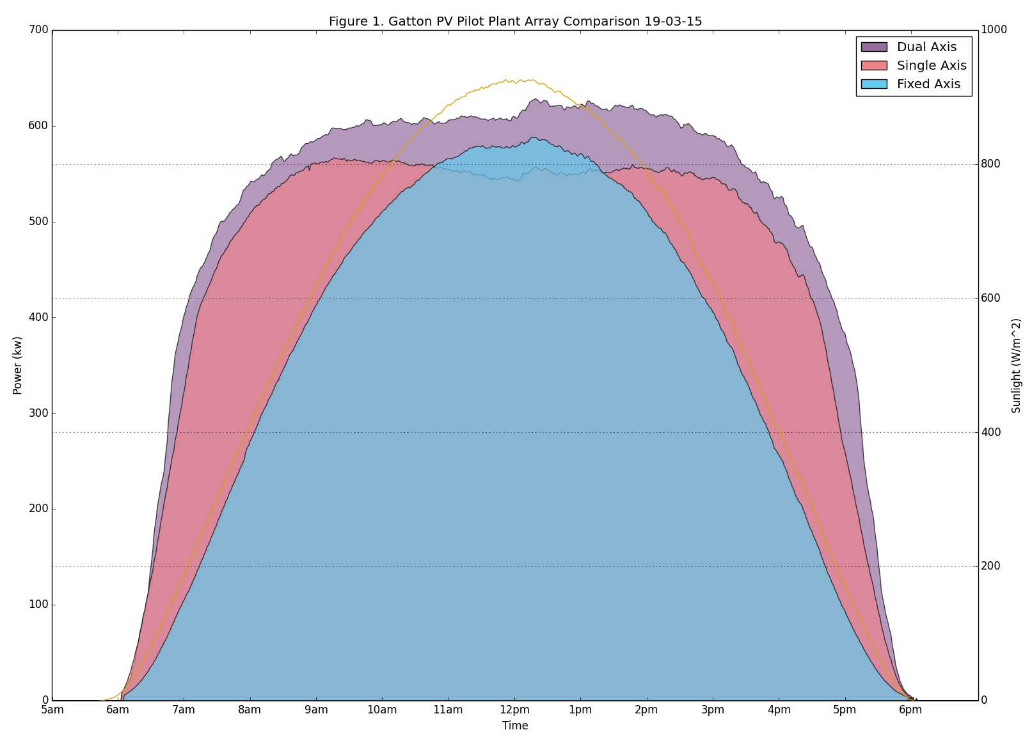

**Figure 12:** Comparison of the power generated for a fixed solar panel, single axis solar tracker and dual axis solar tracker [130].

The quality of solar resources available is derived using satellite imagery for the global horizontal irradiance and direct normal irradiance [78]. For REZs, the resources are aggregated across multiple sites as there is little variance in the solar resources available from site to site within a small geographic area. For existing generators, the resources for the specific site are used [78].

**Wind Trace Data**

Generation trace data for wind is split into two categories, medium-quality and high-quality. For a site to have medium quality wind resources, the site must be within the top 30% of all sites assessed, in terms of resource quality, excluding high quality sites within the REZ [79]. High quality wind resources are defined as areas with wind resources in the top 10% of the sites assessed. Each REZ has a limited amount of medium-quality and high-quality wind resources available as shown in Figure 13. However, AEMO does not provide the exact number of medium- and high-quality wind sites that are developed. AEMO does provide the build limits for medium- and high-quality wind in their assumptions workbook [131] which is shown in Table 5.

As shown in Figure 13, in each of the South Australia REZs, high quality wind resources are the minority. Since high-quality wind resources in each REZ is the minority, generation data was created using the medium generation traces. Another observation from the figure is the current build limitations of each REZ due to current network infrastructure. Notably for SA, the current build limits are below the available renewable resources, indicating the need for REZ expansion projects.

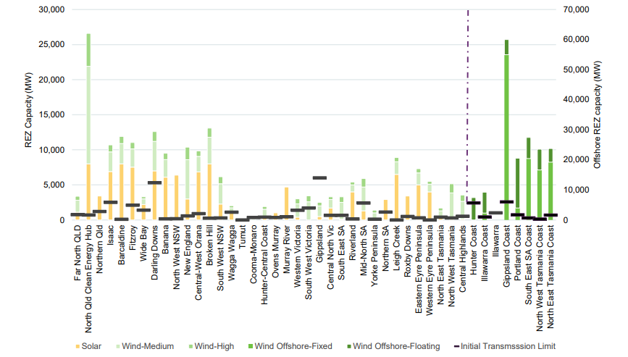

**Figure 13:** The total amount of renewable energy capacity available in each REZ along with the current transmission limits of each REZ [79].

**Table 5:** Medium and high quality wind resource build limits per REZ [131].

|  |  |  |
| --- | --- | --- |
| REZ | Medium Wind Generation Limit (MW) | High Wind Generation Limit (MW) |
| South East SA | 2400 | 800 |
| Riverland | 1000 | 400 |
| Mid-North SA | 3400 | 1200 |
| Yorke Peninsula | 1000 | 400 |
| Northern SA | 0 | 0 |
| Leigh Creek | 1800 | 600 |
| Roxby Downs | 0 | 0 |
| Eastern Eyre Peninsula | 1700 | 600 |
| Western Eyre Peninsula | 1100 | 400 |

**Hydrogen Generation**

Due to the level of uncertainty surrounding hydrogen, generation traces on a half hourly basis are not provided by AEMO [78]. Furthermore, as of the 2024 ISP, AEMO no longer models hydrogen generation as its own component and instead aggregates it with flexible gas [33]. Due to these limitations, hydrogen generation is not considered in the base generation source of any models but is instead used in the sensitivity analyses to explore how hydrogen could complement renewable energy resources and reduce the overall reliance on battery storage.

**Creating Traces**

Once the correct instances of the trace data were downloaded, a mapping table was created which mapped each site and REZ to one of AEMO’s trace data files. This mapping table also included each sites’ capacity for each year in AEMO’s forecast period. The structure of the mapping table in shown in Table 6 below.

**Table 6:** Structure of the renewable energy generation mapping table.

|  |  |  |  |  |  |
| --- | --- | --- | --- | --- | --- |
| Site Name | Type | File Name | 2025 | 2026 | … |
| <Site Name> | <Solar/Wind> | <Site Name> RefYear4006.csv | <FY 2025 Capacity> | <FY 2026 Capacity> |  |

Before diving into the code used to create the traces, it is important to understand the structure of AEMO’s trace data. The structure of the downloaded files is shown in Table 7. As illustrated in the table, the year, month and day are in separate columns. To make the data frame easier to work with, one of the first steps was to merge these columns into a single date time column. Furthermore, the generation amount for each half hour period was spread across 48 columns. For example, the “1” column and “2” column represent the first half hour period of the day and the second half hour period of the data, respectively. Therefore, the year, month, and day columns had to be merged and the hour hourly columns unpivoted.

**Table 7:** AEMO’s generation trace file structure.

|  |  |  |  |  |  |
| --- | --- | --- | --- | --- | --- |
| Year | Month | Day | 1 | 2 | … |
| [2024, 2053] | [1, 12] | [1, 31] | [0, 1] | [0, 1] | [0, 1] |

# Demand

The following chapter is split into three sections. The first section describes the demand terms used by AEMO. This importantly covers the nuances associated with each to avoid confusion. The next section breaks down how AEMO’s demand was sourced and used to create traces. Finally, the regional demand division and mapping is discussed using ElectraNet’s data.

## Breaking Down AEMO’s Demand Terms

The following subsections provide a more in depth look at some of the demand terms used by AEMO.

### Operational Demand, Delivered Demand and Underlying Demand

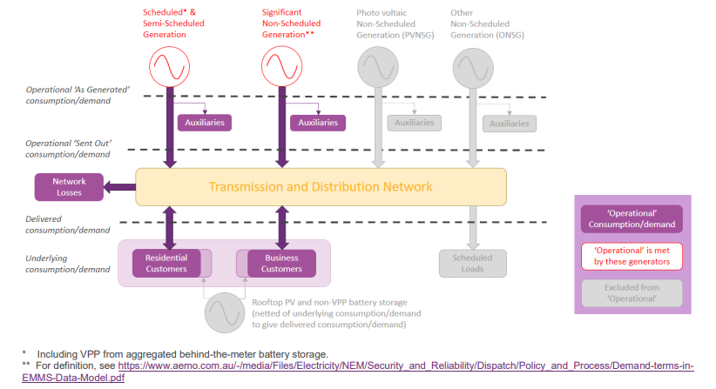The term operational demand is best described with the aid of Figure 14. As shown in Figure 14, operational demand also includes transmission and distribution network losses. Figure 14 also splits operational demand into “as generated” and “sent out”. Operational “as generated” demand is the demand that is inclusive of generator auxiliary units whereas operational “sent out” excludes generator auxiliary amounts. These categorisations are further illustrated in Figure 15.

**Figure 14:** AEMO’s definition of different demand terminologies [80].

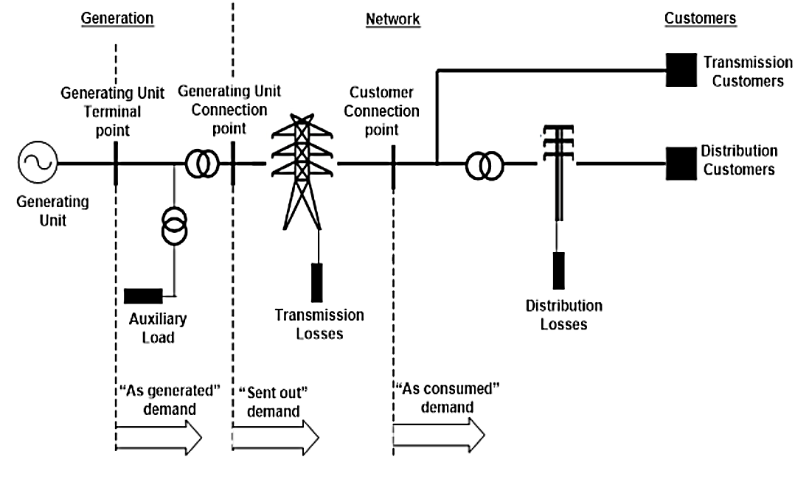

**Figure 15:** Visual comparison of “as generated”, “sent out”, and “as consumed” demand.

Another way of viewing operational demand is outlined in Figure 16. The categories presented here are used in AEMO’s EMMS Data Model.

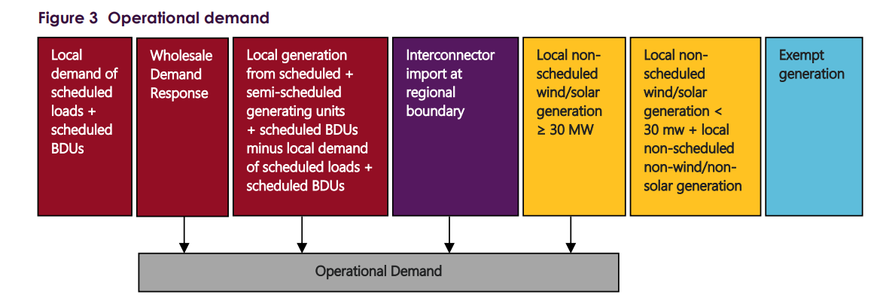

**Figure 16:** Operational demand definition from EMMS Data Model [120].

For modelling purposes, AEMO uses operational demand “sent out”. Therefore, when the term “demand” is used throughout the report, it refers to the operational demand “sent out”.

As part of their modelling, AEMO creates half hourly demand traces for each region in the NEM. Demand traces are provided for every scenario’s ODP. The half-hourly demand trace is defined by AEMO as ‘OPSO_MODELLING’, a variant of operational demand which is described in Eq. (2.1(2.1)(2.1). In words, OPSO_MODELLING is the demand the grid must meet, after the impact of rooftop PV and PVNSG, minus interconnector losses, plus coordinated EV charging to lift minimum demand [121].

|  |  |
| --- | --- |
| $$OPSO_MODELLING=Operational Demand \left(Sent Out\right)-Interconnector Losses \\ + Coordinated EV Charging$$ | (2.1) |

A nuance of OPSO_MODELLING is its inclusion of storages. AEMO forecasts battery storage in three different categories, passive consumer energy resources, coordinated consumer energy resources (CER), and utility scale storage. Coordinated CER refers to storage that is managed as part of a VPP which can consist of both batteries and EVs [33] whereas passive CER storage refers to CER storage that is not included in VPPs. As was shown in Figure 14, operational demand can be met by VPPs and thus the impact of coordinated CER is not included in OPSO_MODELLING. Therefore, when the models created for this project as used to calculate the amount of storage required to meet demand, it includes both coordinated CER and utility-scale batteries. Passive CER storage is modelled into OPSO_MODELLING [121]. CER can smooth out the ‘duck curve’ and help flatten the demand curve.

Two other demand terms that are related to the operational demand are delivered demand and underlying demand. AEMO’s definition of these demand terms is best described with the aid of Figure 17. Underlying demand is the demand that must be met by the entire grid including rooftop PV and ONSG and PVNSG.

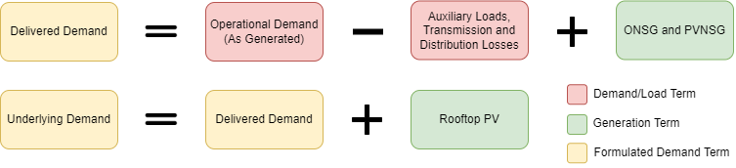

**Figure 17:** Explanation of demand terminologies in equation form [121].

### Native Demand and Scheduled Demand

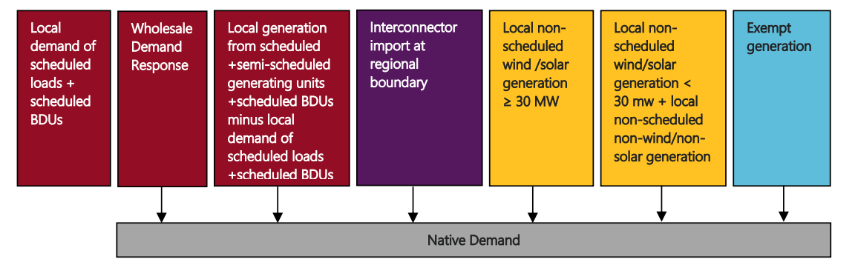In addition to operational demand, AEMO also uses the terms native demand and scheduled demand. Native demand, shown visually in Figure 18, is operational demand plus demand met by small non-scheduled generations. However, native demand does not include the demand met by behind the meter generation such as rooftop PV and battery storage. Native demand is used by AEMO for 10% and 50% POE seasonal maximum forecasts as part of medium-term projected assessment of system adequacy. Thus, it is not expected to be prevalent in determining storage requirements.

**Figure 18:** Native demand definition from EMMS Data Model [120].

The last type of demand is scheduled demand, shown visually in Figure 19, which defines the demand that is met by local scheduled, semi-scheduled and generation imports to a region. This excludes the demand that is met by non-scheduled wind and solar and other non-scheduled generation. Scheduled demand is used by AEMO as a basis to determine regional prices and dispatch targets for scheduled and semi-scheduled generating units. For further discussion on the aforementioned types of demand, refer to AEMO’s Demand Terms in EMMS Data Model document [122].

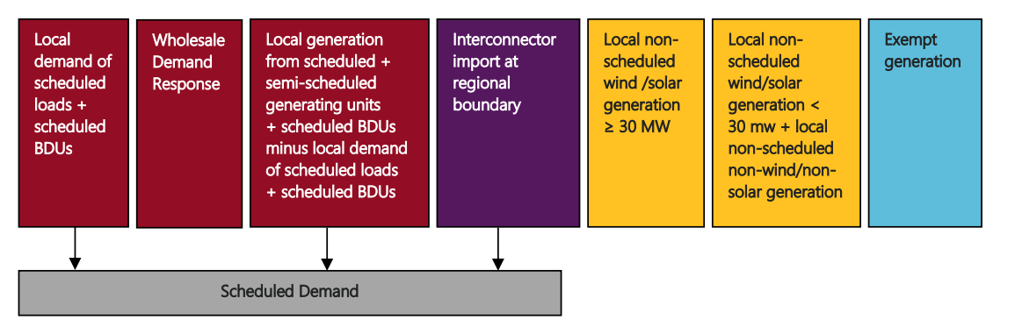

**Figure 19:** Scheduled demand definition from EMMS Data Model [120].

### Demand Side Participation

Since 2017, AEMO has tracked and forecasted the amount of demand side participation (DSP) in the NEM [123]. DSP refers to activities taken by proponents in an electricity grid to reduce demand [82]. This can either be done by reducing a non-scheduled load or dispatching unscheduled generation [82]. As depicted in Figure 20, demand flexibility is incorporated into the supply and demand forecasted. However, DSP due to price or reliability triggers is modelled separately [82]. AEMO considers this DSP capacity as dispatchable, meaning that it can be used alongside renewable energy generation to reduce demand. One caveat to this dispatchable capacity is that AEMO aggregates each component. The issue with this is that as of the 2024 ISP, AEMO imposes a daily limit of a maximum 2-hour continuous operation for DSP related to reliability [124]. Due to the limitations of the modelling, the models presented limit DSP to 2 hours of equivalent maximum operation each day.

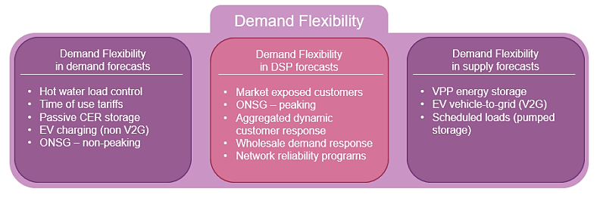

**Figure 20:** Demand flexibility overview and relation to other AEMO forecasts [82].

### Effects of Coordinated EV Charging and CER on Demand

One of the most significant trends that has been occurring over the past decade is the increase of the ‘duck curve’. Due to increased amounts of rooftop solar, the demand during the middle of the day has significantly increased. This has caused reliability issues in the grid that was not designed for large amounts of bidirectional energy flow.

Figure 21 outlines the impact of coordinated EV charging on the operational demand. As shown in the figure, coordinated EV charging helps lift the minimum demand. This also means that the afternoon peak is not as drastic as consumers opt to charge in the middle of the day when there is an excess of energy.

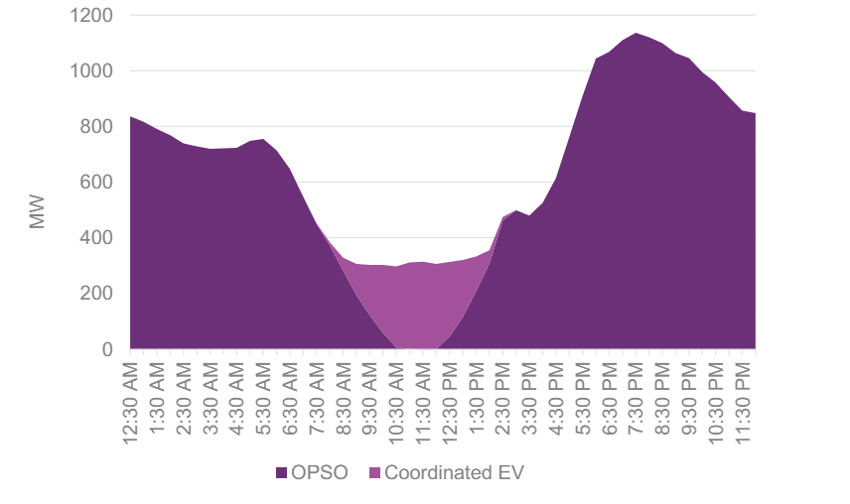

**Figure 21**: Example of the effect that coordinated EV charging can have on the demand curve. As highlighted in the figure, charging in the middle of the day helps lift the demand curve, smoothing out the minimum demand [121].

Another method that can be used to reduce the duck curve is with storage. An example of this method is shown in Figure 22. When demand is low, energy storages part of a VPP can be charged, helping lift the minimum demand. This stored energy can then be used to reduce the evening peak. The use of CER demonstrates how batteries can be used to temporally shift generation.

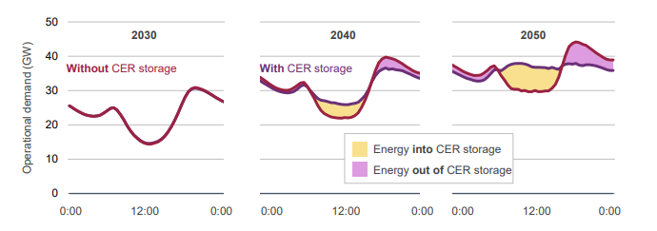

**Figure 22:** Example of how CER storage can be used to flatten the demand curve [33].

## Demand Data

AEMO splits SA into two regions, Central SA (CSA) and South East SA (SESA) as depicted in Figure 23. The connections between the regions are facilitated as outlined in the points below [79]:

* CSA – SNSW (Bundy to Buronga via two 330kV circuits)
* CSA – VIC (Monash to Redcliffs via HVDC cable)
* CSA – SESA (Tailem Bend to Black Range via two 275kV circuits and Tailem Bend to Keith via one 132kV circuit)
* SESA – VIC (South East to Heywood via two 275kV circuits)

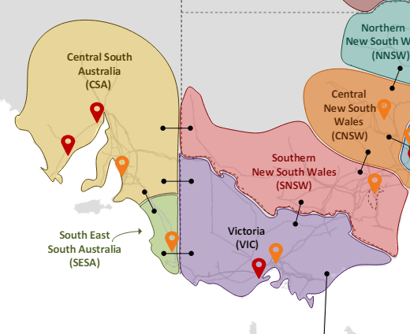

**Figure 23:** AEMO’s regional breakdown of the southern part of the NEM. SA is divided into two distinct regions, CSA and SESA. The connections between the regions are also depicted in the figure [78].

Demand traces are provided for these two SA regions in the supporting material of AEMO’s ISP. The relevant zip file containing the demand trace data is shown in Figure 24.



**Figure 24:** Demand trace data location.

After unzipping the downloaded file, the demand traces were found in the following file location.

*\2024 ISP Model\2024 ISP Step Change\Traces\demand*

The CSA and SESA demand traces are named:

* CSA_RefYear_4006_STEP_CHANGE_POE10_OPSO_MODELLING
* SESA_RefYear_4006_STEP_CHANGE_POE10_OPSO_MODELLING

These traces were then combined, using a similar process to the one documented for the generation data. This resulted in the creation of the OPSO_MODELLING demand trace for SA. One caveat of OPSO_MODELLING is that hydrogen demand is not included. AEMO does not model hydrogen at such a scale due to the uncertainties surrounding the technology [78]. Although hydrogen is not given on a half hourly basis, the total annual demand of hydrogen is given by AEMO. A simplistic method is to divide the annual amount by the number of half hour periods in a year and add this to each half hour period. However, the creation of hydrogen would typically occur at times of low demand and excess renewable energy generation so that renewable hydrogen, a clean source of energy, would be produced [132]. Therefore, the hydrogen component of demand is added in a post processing step in half hour periods where the net demand is negative.

AEMO produces the annual hydrogen load amounts in their Electricity Forecasting Data Portal [133]. To find SA’s data, filters were applied as outlined in Figure 25. A pivot table was used in Excel to sum over each of the subcategories. This resulted in the annual hydrogen load amounts in TWh as depicted in Table 8.

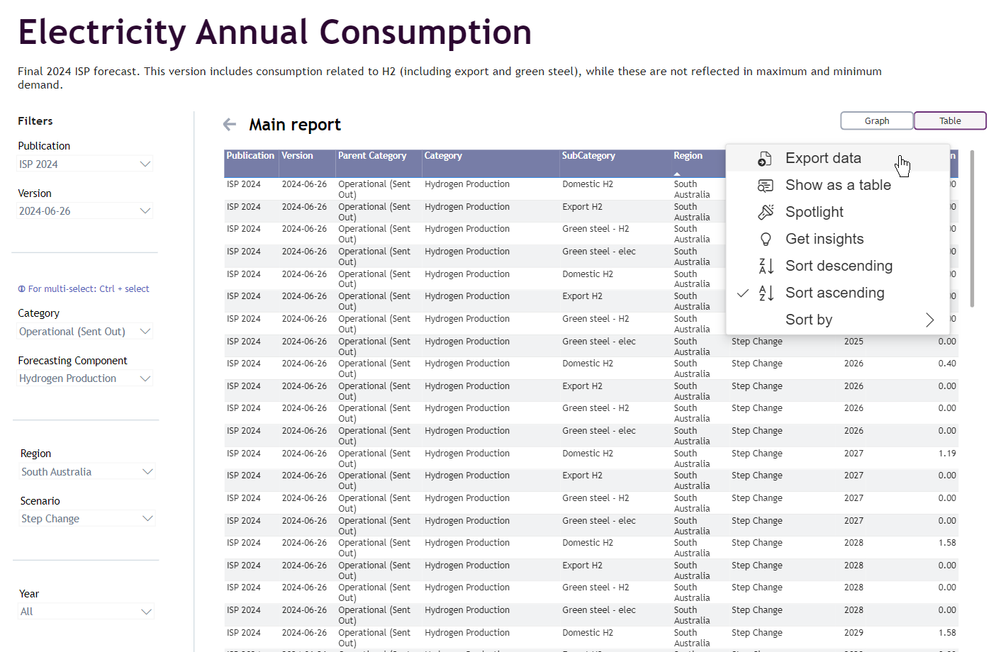

**Figure 25:** Filters applied to export the annual hydrogen demand data.

**Table 8:** Forecasted hydrogen demand in SA in the *Step Change* scenario.

|  |  |
| --- | --- |
| Financial Year Ending | Hydrogen Demand (TWh) |
| 2025 | 0.0089 |
| 2026 | 0.3987 |
| 2027 | 1.149 |
| 2028 | 1.548 |
| 2029 | 1.887 |
| 2030 | 2.316 |
| 2031 | 3.054 |
| 2032 | 3.174 |
| 2033 | 3.144 |
| 2034 | 3.537 |
| 2035 | 2.747 |
| 2036 | 2.998 |
| 2037 | 3.279 |
| 2038 | 3.792 |
| 2039 | 3.608 |
| 2040 | 3.906 |
| 2041 | 3.881 |
| 2042 | 4.824 |
| 2043 | 4.566 |
| 2044 | 4.859 |
| 2045 | 5.001 |
| 2046 | 4.775 |
| 2047 | 4.832 |
| 2048 | 4.857 |
| 2049 | 5.547 |
| 2050 | 5.575 |
| 2051 | 5.691 |
| 2052 | 5.827 |

When adding the hydrogen load to the demand, a few assumptions were made. First, it was assumed that hydrogen load is flexible and could be added to any desired half hour period. This assumption is justified through the studies that have been conducted on the ramp rates of electrolysers. Studies such as the one by Deloitte [134] and Macquire [135] demonstrate that hydrogen electrolysers can ramp in the range of 10% of the total capacity each second. The second assumption is that the generation plants will choose to operate when there is net negative demand. This may not be the case as generators may have signed agreements to produce a certain amount of hydrogen each month. If there are limited net negative demand times, then they will be unable to reach their quota. However, due to the uncertainty surrounding the operation of these plants, these assumptions are considered reasonable.

The hydrogen load trace is created using the python script below. This script performs the following high-level tasks:

* Reads in the demand, total solar, and total wind traces
* Calculates the net demand by subtracting the total renewable generation from the demand
* Determines the number of half hour periods the net demand is negative.
* Divides the annual hydrogen demand by the number of negative half hour periods.
* Adds the hydrogen demand to each of these half hour periods.

The last step involved in the demand data preparation is to collate the annual capacity and annual use of DSP. AEMO’s DSP forecasts for SA can be found in the 2024 ISP Generation and Storage Outlook workbook. The relevant worksheet for this information is the “Summary” sheet as shown in Figure 26. To ensure the correct CDP was selected, CDP14 was chosen from the “Select case” dropdown.

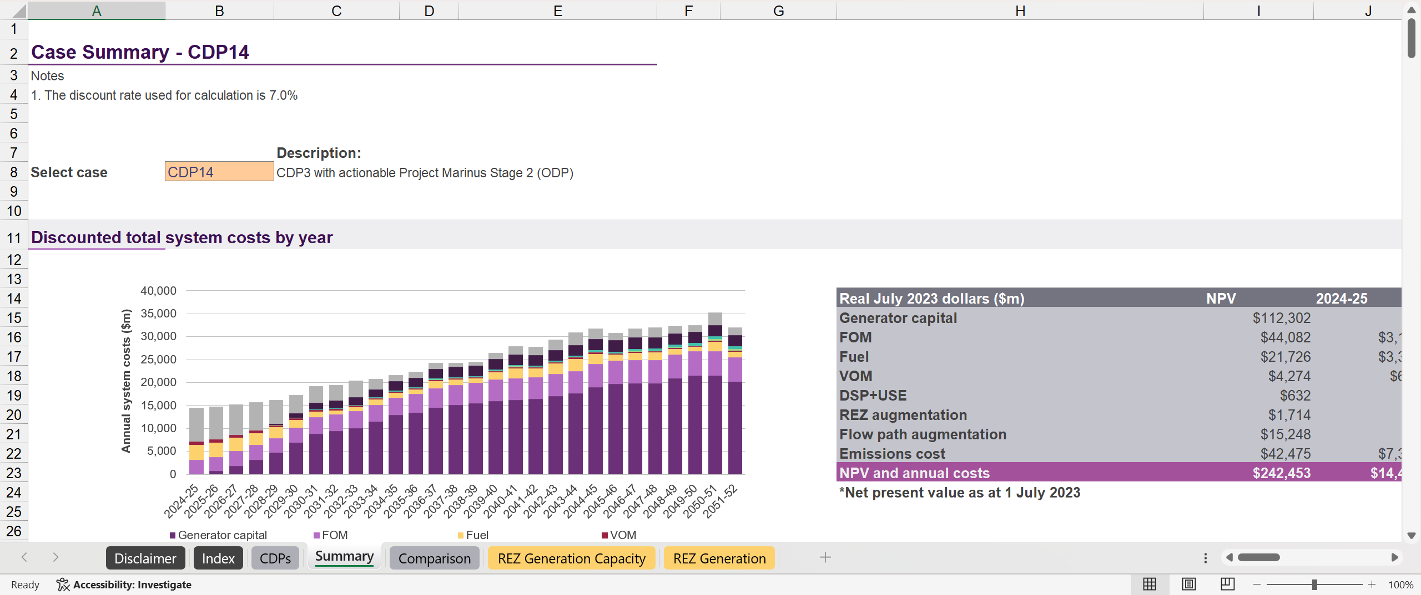

**Figure 26:** AEMO’s Summary worksheet from the ISP Generation and Storage Outlook workbook.

To obtain the relevant DSP information, the “SA capacity by year” and “SA generation by year” sections of the worksheet were investigated, see Figure 27 and Figure 28, respectively. The DSP figures for the forecast years were then copied and pasted into a separate Excel workbook.

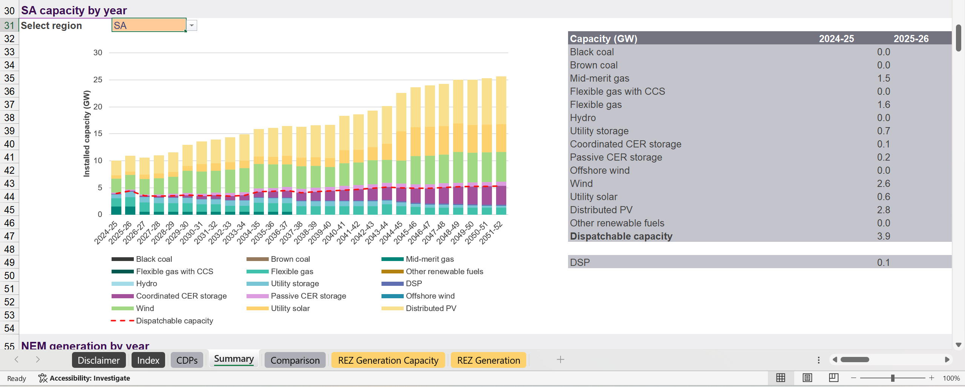

**Figure 27:** Generation capacity by year section.

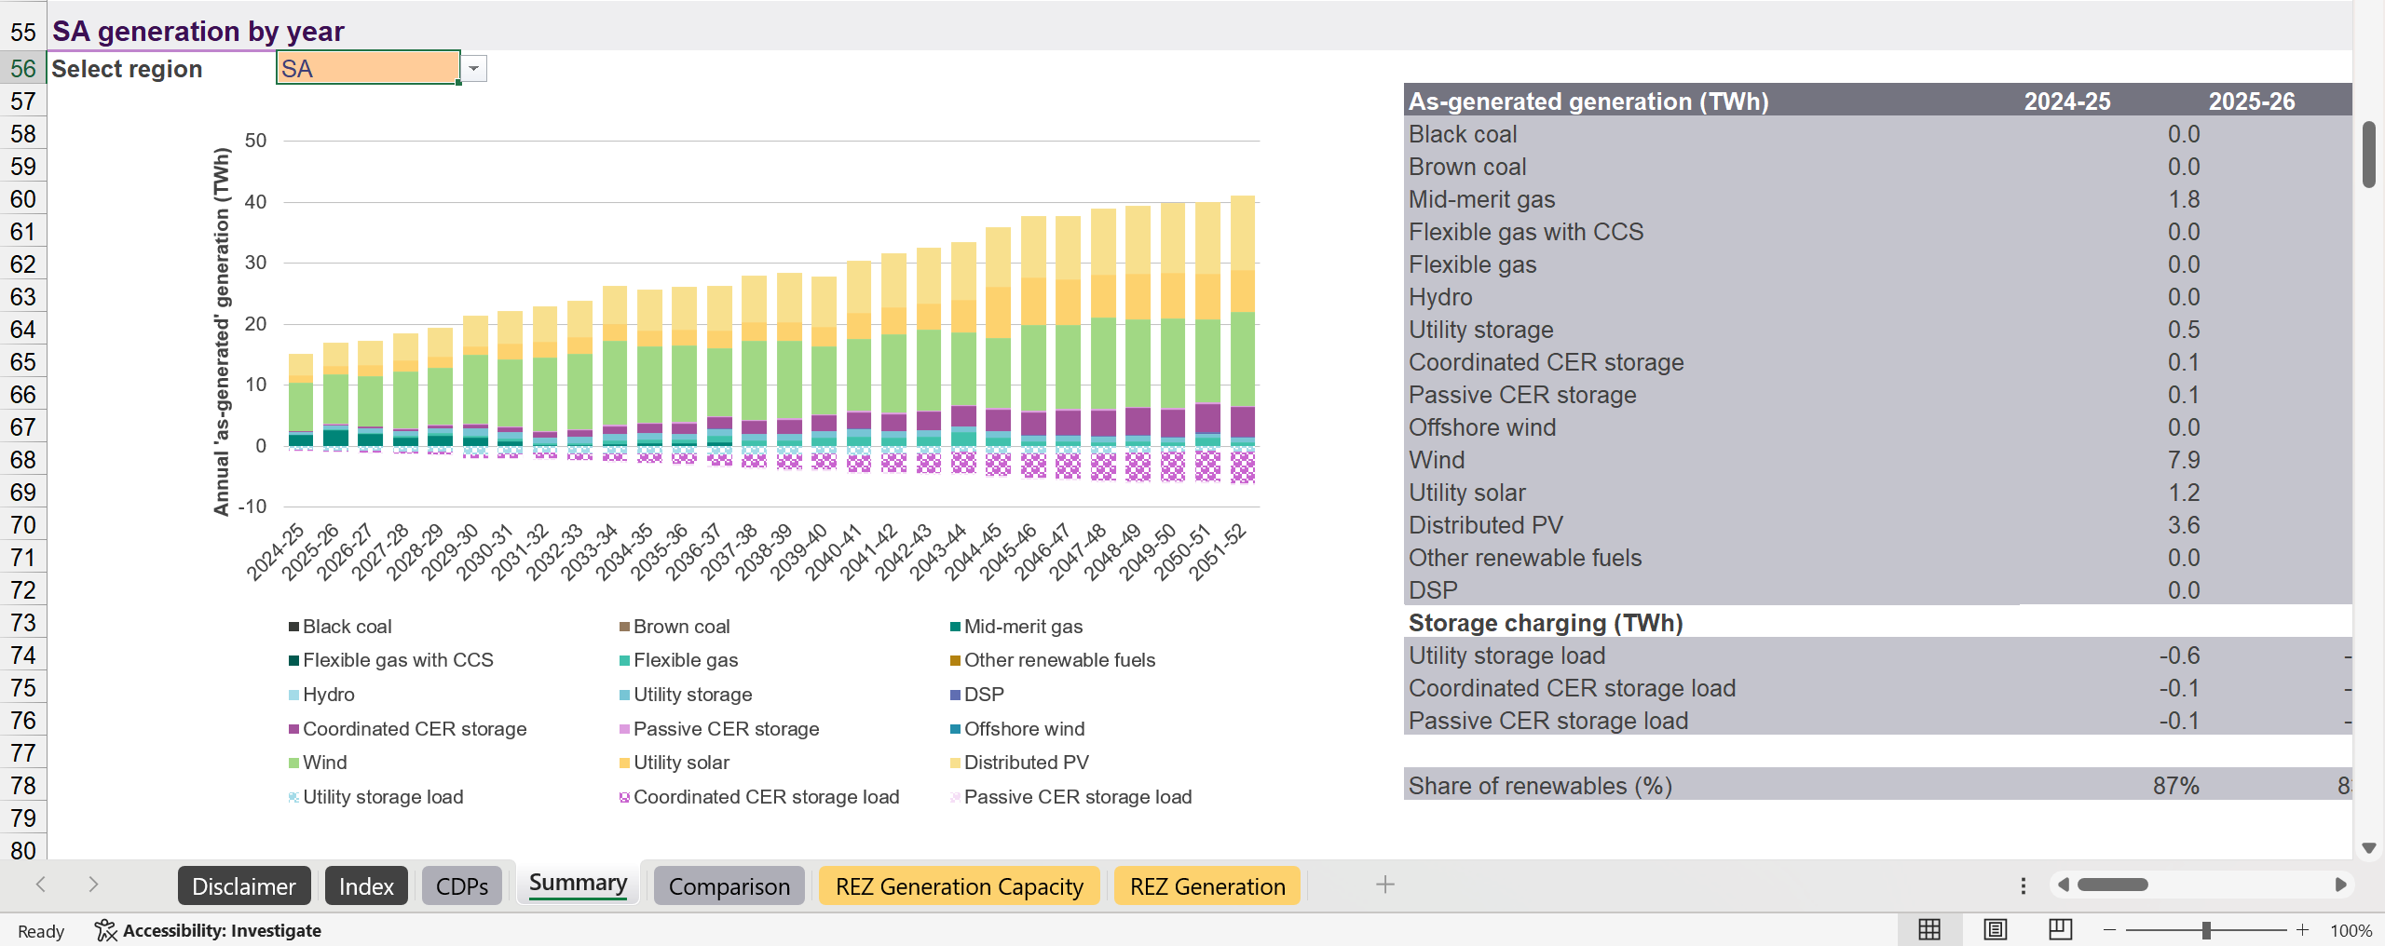

**Figure 28:** Generation totals by year section.

AEMO reports annual forecast totals in FY whereas the modelling of this project is completed in CY. To convert the FY forecasts to CY forecasts, Eq. (2.2) is used as an approximation.

|  |  |
| --- | --- |
|  | (.) |

It is acknowledged that this conversion will not be as accurate as comparison in FYs, but CYs offers simplifications for the models developed. The DSP components for SA is shown in Table 9.

**Table 9:** DSP capacity and generation forecasts for SA.

|  |  |  |
| --- | --- | --- |
| Calendar Year | DSP Capacity (MW) | DSP Generation (MWh) |
| **2025** | 55.25 | 96 |
| **2026** | 60.25 | 0.00106 |
| **2027** | 65.7 | 0.00118 |
| **2028** | 71.18 | 928 |
| **2029** | 76.69 | 8164 |
| **2030** | 82.59 | 18686 |
| **2031** | 88.57 | 11450 |
| **2032** | 94.47 | 2016 |
| **2033** | 100.6 | 29816 |
| **2034** | 107.2 | 55527 |
| **2035** | 114.3 | 44611 |
| **2036** | 121.9 | 62856 |
| **2037** | 129.4 | 75346 |
| **2038** | 136.6 | 45331 |
| **2039** | 143.4 | 41489 |
| **2040** | 150 | 88562 |
| **2041** | 156.8 | 88559 |
| **2042** | 163.6 | 41452 |
| **2043** | 170.2 | 66958 |
| **2044** | 176.4 | 94809 |
| **2045** | 182 | 69090 |
| **2046** | 187 | 89381 |
| **2047** | 192.2 | 117820 |
| **2048** | 197.3 | 116054 |
| **2049** | 202.6 | 123772 |
| **2050** | 206.1 | 192871 |
| **2051** | 207.7 | 224422 |

## Regional Demand Division

An “honours” region refers to a region defined by our work.

As part of their reporting, ElectraNet calculates the annual demand for every substation in their system such that demand is not doubled counted. For example, Monash substation is not counted as the demand on that substation is already considered by the North West Bend substation. Once this data is collected, it is then aggregated by the ElectraNet regions, which provides a percentage breakdown of demand in their system. Table 10 provides the overall regional breakdown of demand and Table 11 provides a more detailed view that includes the sub regional breakdown.

**Table 10:** ElectraNet regional breakdown of demand in SA.

|  |  |
| --- | --- |
| ElectraNet Region | SA Demand Percentage |
| Adelaide Metro | 57.65% |
| Eastern Hills | 7.320% |
| Eyre Peninsula | 10.19% |
| Mid North | 9.200% |
| Riverland | 5.680% |
| South East | 8.680% |
| Upper North | 1.280% |

**Table 11:** ElectraNet regional breakdown of demand in SA including relevant sub regions.

|  |  |  |  |
| --- | --- | --- | --- |
| Region | Sub Region | Regional Demand Percentage | Statewide Demand Percentage |
| **Adelaide Metro** |  |  | **57.65%** |
|  | Eastern Suburbs | 16.83% | 9.702% |
|  | Northern Suburbs | 24.21% | 13.96% |
|  | Southern Suburbs | 36.88% | 21.26% |
|  | Western Suburbs | 22.08% | 12.73% |
| **Eastern Hills** |  |  | **7.320%** |
|  | Angas Creek | 12.75% | 0.9333% |
|  | Kanmantoo | 0.80% | 0.0586% |
|  | Mannum | 4.08% | 0.2987% |
|  | Mobilong | 23.91% | 1.750% |
|  | Mt Barker and Mt Barker Sth | 58.46% | 4.279% |
| **Eyre Peninsula** |  |  | **10.19%** |
|  | Port Lincoln | 19.02% | 1.938% |
|  | Stony Point Distribution | 0.05% | 0.0051% |
|  | Whyalla and Whyalla Central | 72.15% | 7.352% |
|  | Wudinna | 5.23% | 0.5329% |
|  | Yadnarie | 3.55% | 0.3617% |
| **Mid North** |  |  | **9.200%** |
|  | Ardrossan West | 4.29% | 0.3947% |
|  | Baroota | 1.29% | 0.1187% |
|  | Brinkworth | 2.30% | 0.2116% |
|  | Clare North | 6.83% | 0.6284% |
|  | Dalrymple | 3.41% | 0.3137% |
|  | Dorrien | 31.93% | 2.938% |
|  | Hummocks | 4.14% | 0.3809% |
|  | Kadina East | 5.19% | 0.4775% |
|  | Port Pirie Network | 20.67% | 1.902% |
|  | Templers | 15.16% | 1.395% |
|  | Waterloo | 4.78% | 0.4398% |
| **Riverland** |  |  | **5.680%** |
|  | Berri | 78.73% | 4.472% |
|  | North West Bend | 21.27% | 1.208% |
| **South East** |  |  | **8.680%** |
|  | Blanche | 36.67% | 3.183% |
|  | Keith | 12.27% | 1.065% |
|  | Kincraig | 12.89% | 1.119% |
|  | Mt Gambier | 21.09% | 1.831% |
|  | Penola West | 6.03% | 0.5234% |
|  | Snuggery Industrial | -16.00% | -1.389% |
|  | Snuggery Rural | 8.30% | 0.7204% |
|  | Tailem Bend | 18.75% | 1.628% |
| **Upper North** |  |  | **1.280%** |
|  | Davenport West | 92.05% | 1.178% |
|  | Leigh Creek South | 3.51% | 0.0449% |
|  | Mt Gunson | 0.41% | 0.0052% |
|  | Neuroodla | 4.03% | 0.0516% |

To transfer this data to the honours regions, several differences need to be considered. As shown in Figure 29 below, the Northern suburbs are partly included in the Mid North honours region. Since an exact split of the demand between the Adelaide Metro honours region and the Mid North honours region is unattainable, demand of the Northern Suburbs is split 50-50 between the regions. This means that half of the Northern suburbs demand will be added to the Mid North honours region.

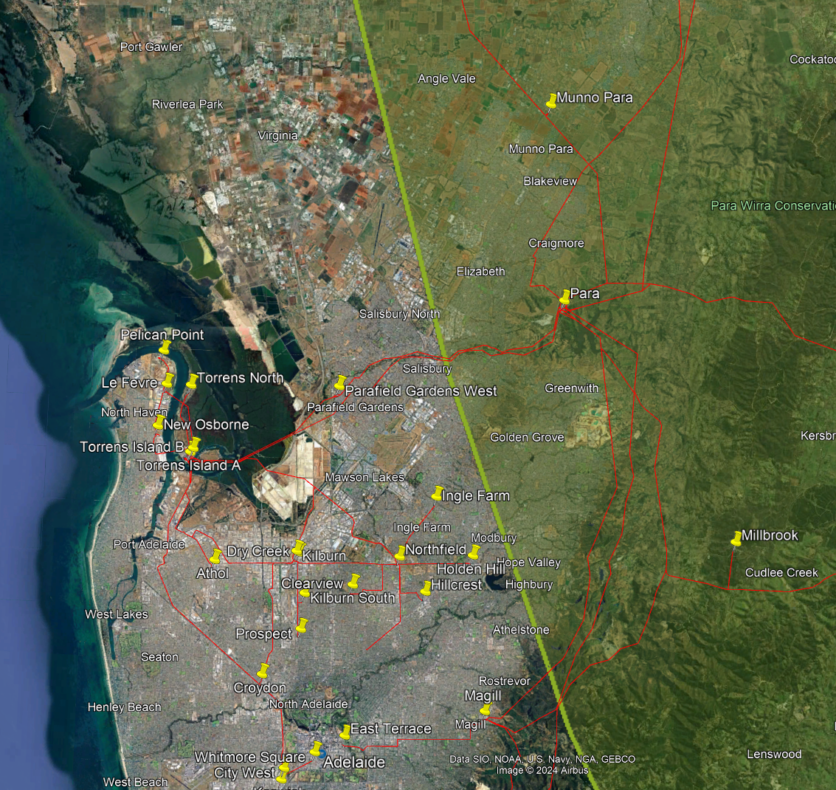

**Figure 29:** Mid North honours regional boundary encompassing approximately half of the Northern suburbs.

The next difference arises in ElectraNet’s Eastern Hills region. Mount Barker substation resides in the Mid North honours region with Mount Barker South substation residing just outside the border as shown in Figure 30 below. Due to their close proximity, Mount Barker South substation is placed in the Mid North honours region. The remainder of ElectraNet’s Eastern Hills region fall within the Mid North honours region.

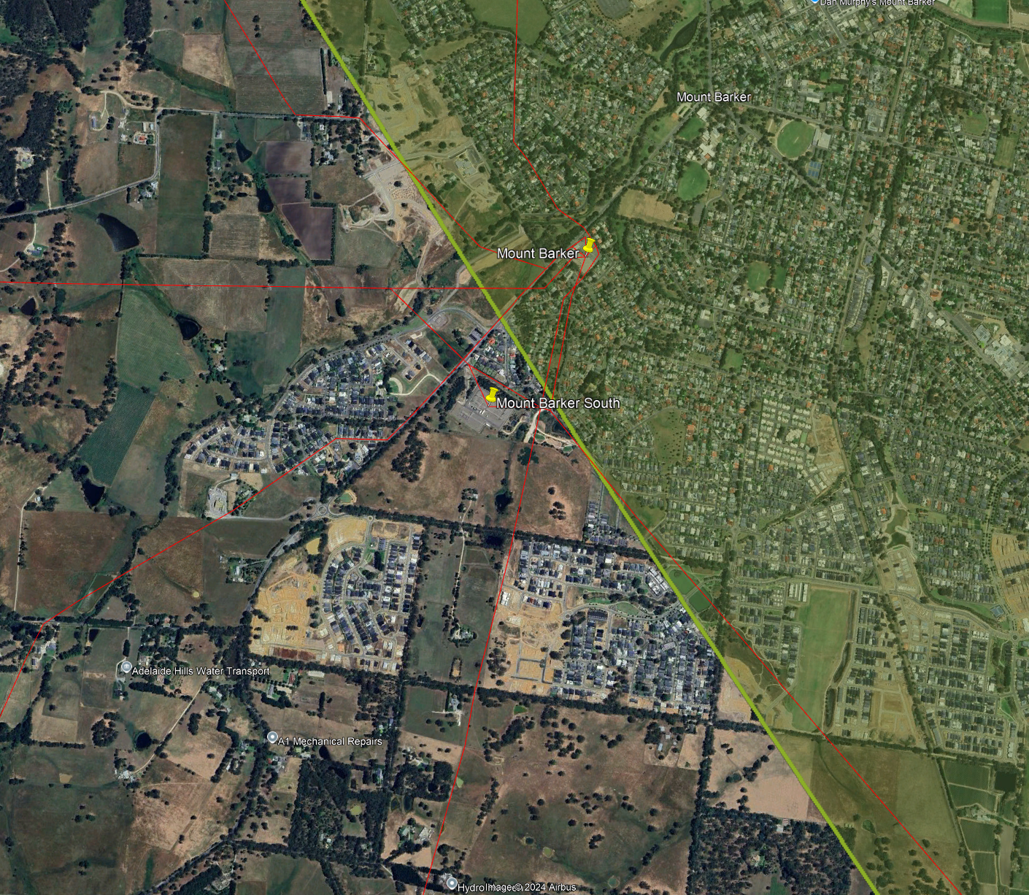

**Figure 30:** Mid North honours regional boundary and the relative locations of Mount Barker and Mount Barker South substations.

Another difference in the honours regional mapping and ElectraNet’s regional mapping occurs in the Eyre Peninsula. In the Eyre Peninsula region, Whyalla and Stony Point fall within the Iron Triangle honours region as shown in Figure 31. Thus, these substations are placed in the Iron Triangle honours region.

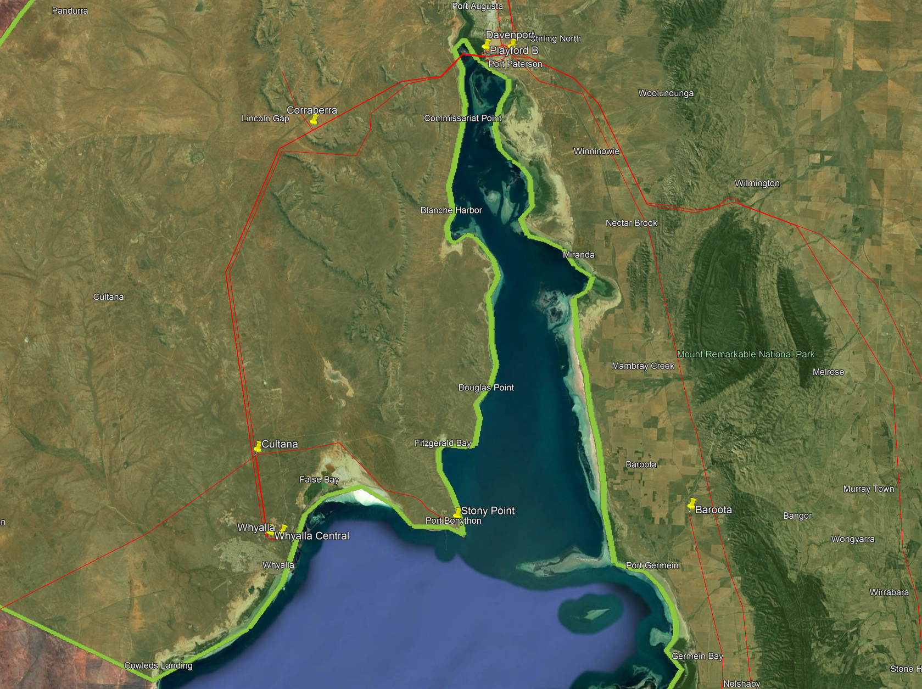

**Figure 31:** Location of Whyalla and Stony Point substation with reference to the Iron Triangle honours region.

The last difference between ElectraNet’s regional splits and the honours regional split occurs in the Iron Triangle honours region. Figure 32 below depicts that all of ElectraNet’s Mid North region fall within the Mid North honours region except for Baroota. Therefore, Baroota is placed in the Iron Triangle honours region.

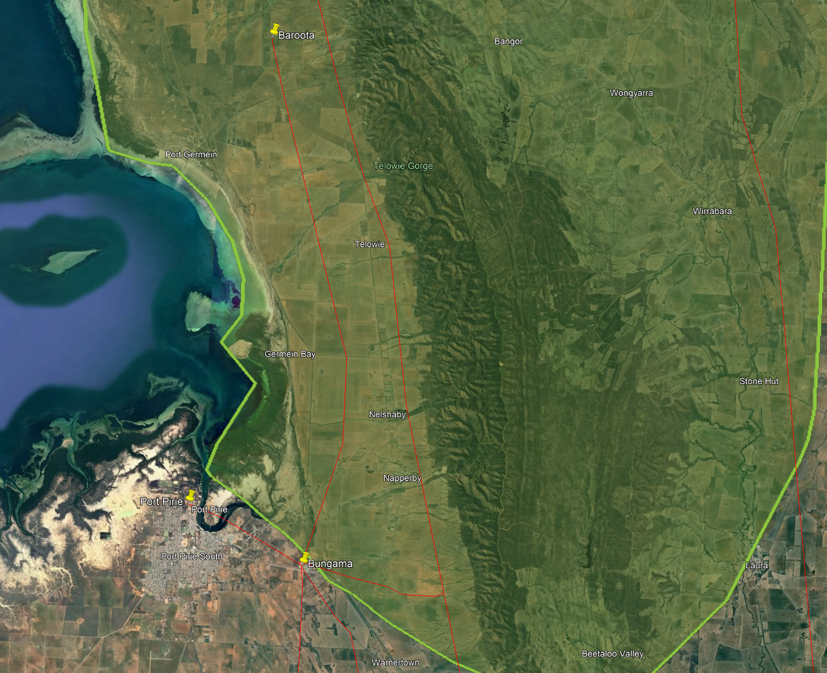

**Figure 32:** Inclusions of Iron Triangle honours region with respect to Baroota substation.

Another aspect that needs to be considered is how the demand breakdown in each region will change over the forecast period. For example, a connection of a large load in the Mid North region would significantly change the current demand breakdown. Due to the uncertainty of the size and location of future load connections, it is assumed that the current regional demand breakdown will approximately be the same in the future, except for one variable, hydrogen loads. AEMO is forecasting hydrogen demand to be responsible for ~25% of the load in SA by 2052. Therefore, the demand breakdown needs to reflect this change over the years.

Currently, there are multiple locations for hydrogen projects as shown in Figure 33, with a majority of the large projects (scale of at least hundreds of MWs) located in either the Eyre Peninsula or Northern SA [171]. Due to the current uncertainty around the feasibility of a hydrogen region and the uncertainty of the hydrogen projects, hydrogen demand is assumed to be split evenly between the Eyre Peninsula honours region and the Iron Triangle honours region.

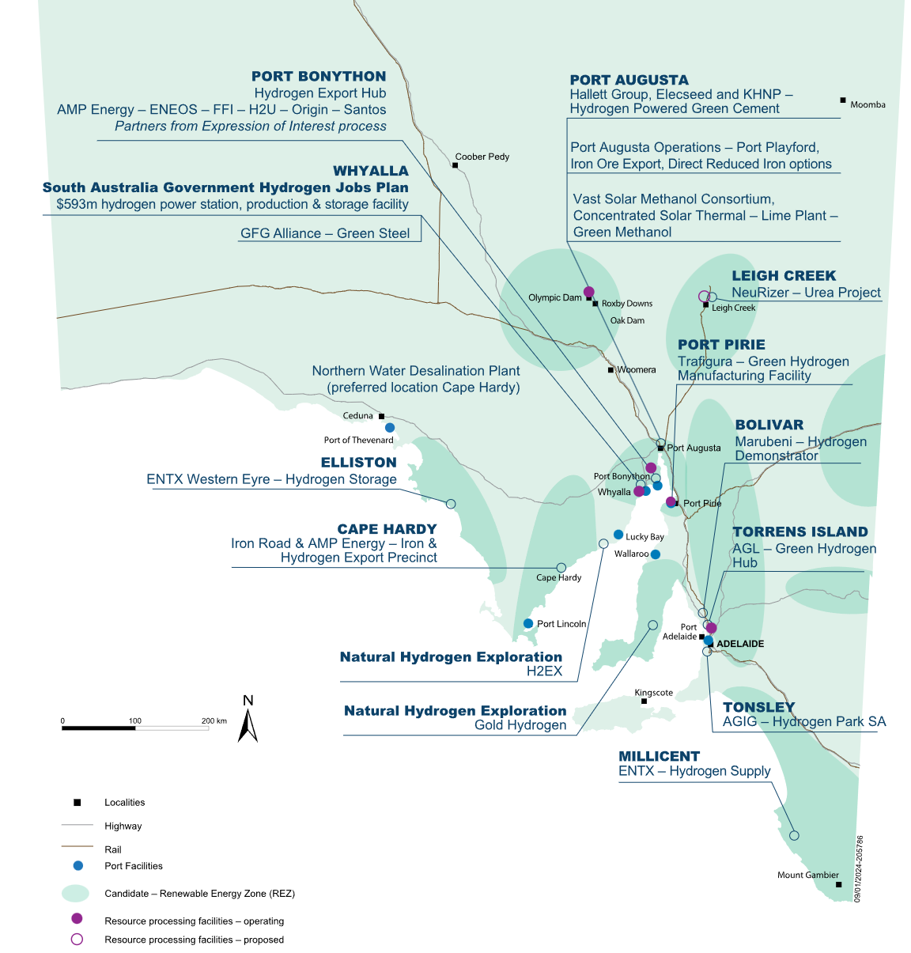

**Figure 33:** Overview of potential hydrogen loads in SA [171].

Since a separate hydrogen trace was created as previously discussed, there is no need to calculate future regional demand splits as it is assumed all regional splits will remain constant and the hydrogen load trace will be split between the Eyre Peninsula honours region and the Iron Triangle honours region. In the event that AEMO adds hydrogen into the overall demand trace, the following mathematical approach can be taken.

To calculate the change in demand over the forecast period of the Eyre Peninsula region and the Northern SA region, it is assumed that currently, no hydrogen load exists in these regions. All future hydrogen demand is expected to be split evenly between these regions. Furthermore, it is assumed that currently, there is negligible hydrogen load in SA, thus, any forecasted hydrogen load only occurs in these said regions. A future improvement to the model is shown in the equations below rather than taking demand to be fixed over the forecast period. To calculate the change in demand percentage of these regions, the following are used:

|  |  |
| --- | --- |
| $${Demand}_{FY}={Demand}_{FY-1}+\frac{{∆Hydrogen Demand}_{FY}}{2}$$ | (2.3) |

An example calculation for the Eyre Peninsula honours region is given below for FY26.

|  |  |
| --- | --- |
| $${Demand}_{Eyre,FY26}={Demand}_{Eyre,FY25}+\frac{{Hydrogen Demand Percentage}_{FY26}}{2}$$ | (2.4) |
| $${Demand}_{Eyre,FY26}=2.833\%+\frac{3.317\%}{2}$$ | (2.5) |
| $${Demand}_{Eyre,FY26}=4.492\%$$ | (2.6) |

The same process is repeated for the Iron Triangle honours region. The next step is to calculate the updated demand percentages for the remaining regions. This is achieved using the following formula:

|  |  |
| --- | --- |
| $${Demand}_{r,FY}={Demand}_{r,FY-1}×\left(\frac{1-{Demand}_{h,FY}}{\sum_{r}{{Demand}_{r,FY-1}}}\right)$$ | (2.7) |

Where $r$ is part of the set of all regions that do not include hydrogen loads and $h$ is the set of regions that include hydrogen loads. The application of this formula is shown for the Adelaide metro region in FY26.

|  |  |
| --- | --- |
| $${Demand}_{Adelaide,FY26}=50.67\%×\left(\frac{1-4.492\%-10.31\%}{50.67\%+0.1018\%+23.38\%+5.680\%+8.68\%}\right)$$ | (2.8) |
| $${Demand}_{Adelaide,FY26}=48.77\%$$ | (2.9) |

This process can then be repeated for each region over every forecasted year.

The final demand breakdown for each honours region is summarised in Table 12 while a detailed version is provided in Table 13.

**Table 12:** Summary of the demand breakdown, not inclusive of hydrogen trace, for each honours region.

|  |  |
| --- | --- |
| Honours Region | SA Demand Percentage |
| Adelaide Metro | 50.67% |
| Eyre Peninsula | 2.833% |
| Iron Triangle | 8.654% |
| Upper North | 0.1018% |
| Mid North | 23.38% |
| Riverland | 5.680% |
| South East | 8.680% |

**Table 13:** Detailed breakdown of the honours regional demand including relevant sub regions.

|  |  |  |  |
| --- | --- | --- | --- |
| Region | Sub Region | Regional Demand Percentage | Statewide Demand Percentage |
| **Adelaide Metro** |  |  | **50.67%** |
|  | Eastern Suburbs | 19.15% | 9.702% |
|  | Northern Suburbs (1/2) | 13.77% | 6.979% |
|  | Southern Suburbs | 41.96% | 21.261% |
|  | Western Suburbs | 25.12% | 12.729% |
| **Eyre Peninsula** |  |  | **2.833%** |
|  | Port Lincoln | 68.42% | 1.938% |
|  | Wudinna | 18.81% | 0.5329% |
|  | Yadnarie | 12.77% | 0.3617% |
| **Iron Triangle** |  |  | **8.654%** |
|  | Stony Point Distribution | 0.0589% | 0.0051% |
|  | Whyalla and Whyalla Central | 84.95% | 7.3521% |
|  | Baroota | 1.371% | 0.1187% |
|  | Davenport West | 13.61% | 1.178% |
| **Upper North** |  |  | **0.1018%** |
|  | Leigh Creek South | 44.15% | 0.0449% |
|  | Mt Gunson | 5.157% | 0.0052% |
|  | Neuroodla | 50.69% | 0.0516% |
| **Mid North** |  |  | **23.38%** |
|  | Northern Suburbs (1/2) | 29.85% | 6.979% |
|  | Ardrossan West | 1.688% | 0.3947% |
|  | Brinkworth | 0.9051% | 0.21% |
|  | Clare North | 2.688% | 0.63% |
|  | Dalrymple | 1.342% | 0.31% |
|  | Dorrien | 12.56% | 2.94% |
|  | Hummocks | 1.629% | 0.38% |
|  | Kadina East | 2.042% | 0.48% |
|  | Port Pirie Network | 8.134% | 1.90% |
|  | Templers | 5.966% | 1.39% |
|  | Waterloo | 1.881% | 0.44% |
|  | Angas Creek | 3.992% | 0.9333% |
|  | Kanmantoo | 0.2505% | 0.0586% |
|  | Mannum | 1.277% | 0.2987% |
|  | Mobilong | 7.486% | 1.7502% |
|  | Mt Barker and Mt Barker Sth | 18.30% | 4.2793% |
| **Riverland** |  |  | **5.680%** |
|  | Berri | 78.73% | 4.472% |
|  | North West Bend | 21.27% | 1.208% |
| **South East** |  |  | **8.680%** |
|  | Blanche | 36.67% | 3.183% |
|  | Keith | 12.27% | 1.065% |
|  | Kincraig | 12.89% | 1.119% |
|  | Mt Gambier | 21.09% | 1.831% |
|  | Penola West | 6.030% | 0.523% |
|  | Snuggery Industrial | -16.00% | -1.389% |
|  | Snuggery Rural | 8.300% | 0.720% |
|  | Tailem Bend | 18.75% | 1.628% |

The comparison of the honours regional division to ElectraNet’s regional split is summarised in Table 14. The main differences are the inclusion of the Iron Triangle region that splits a portion of ElectraNet’s Eyre Peninsula region and Upper North region, and the inclusion of the Eastern Hills region in the Mid North honours region.

**Table 14:** Honours regional mapping compared to ElectraNet’s mapping.

|  |  |
| --- | --- |
| Honours Region | Equivalent ElectraNet Region |
| Adelaide Metro | Adelaide Metro |
| Eyre Peninsula | Eyre Peninsula |
| Iron Triangle | Mixture of Eyre Peninsula and Upper North |
| Upper North | Upper North with the exclusion of Davenport |
| Mid North | Mid North and Eastern Hills |
| Riverland | Riverland |
| South East | South East |

**Sources**

[1] Government of South Australia: Department for Energy and Minding, *"Hydrogen projects in South Australia."* [Online]. Available: <https://www.hydrogen.sa.gov.au/industry/hydrogen-projects-in-south-australia>. [Accessed: Aug. 28, 2024].